**PROJECT REPORT ON CREATING A YOUTUBE THUMBNAIL**

**INTRODUCTION:**

**OVERVIEW:**

The "Designing Eye-Catching YouTube Thumbnails with Canva" project centers on creating visually appealing and compelling thumbnails that attract viewers and entice them to click on your YouTube videos. A well-designed thumbnail can significantly increase the click-through rate and visibility of your content.

**PURPOSE:**

It will be useful for the YouTubers to attract more number of Subscribers.

**PROBLEM DEFINITION AND DESIGN THINKING:**

**EMPATHY MAP:**

IDEATION AND BRAINSTORMING MAP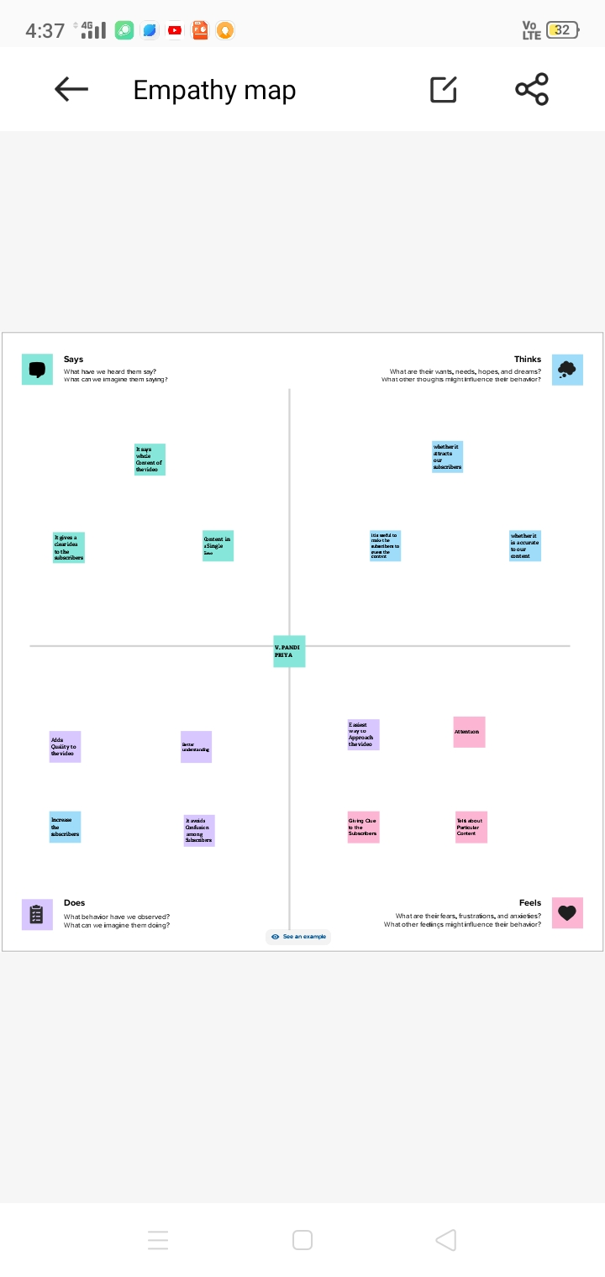

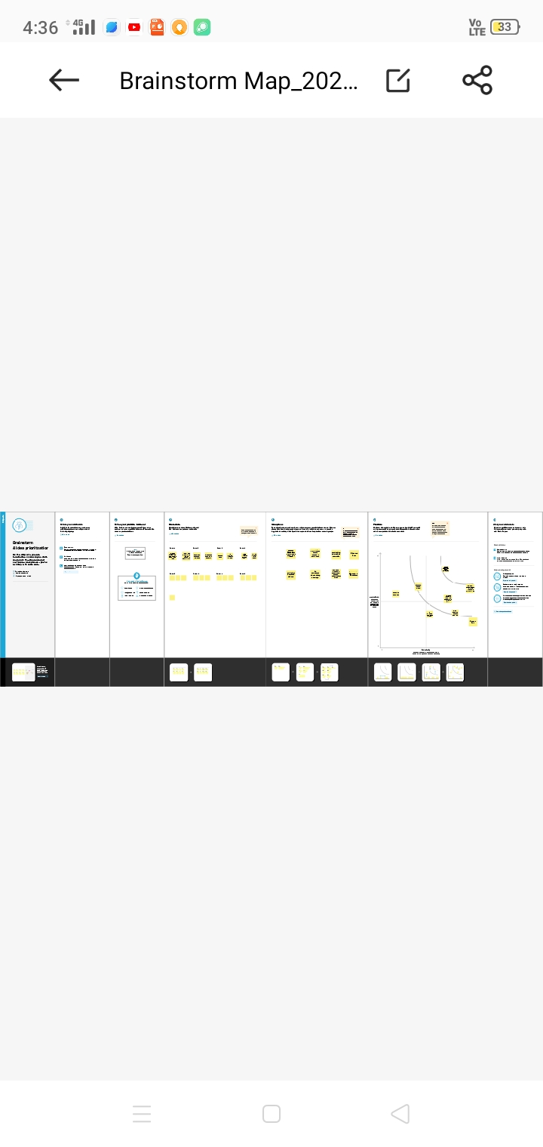**RESULT:**

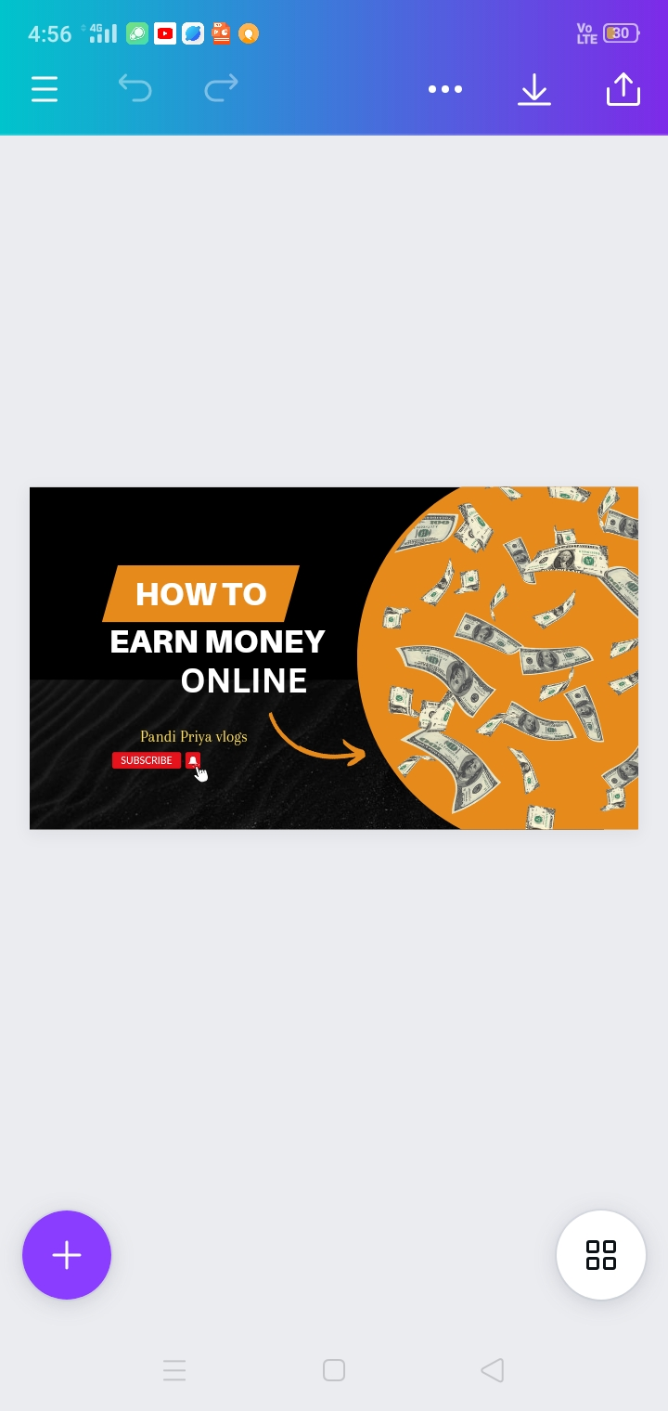**ADVANTAGES:**

1. Helpful to the YouTubers to attract their subscribers.
2. Black and orange background suits good.

**DISADVANTAGES:**

1. Dollar Note can be replaced with Indian Rupee note.

**APPLICATIONS:**

1. It is useful to Youtubers.
2. This YouTube thumbnail can be used in Professional topics.

**CONCLUSION:**

It will be helpful to the YouTubers. It attracts more number of Subscribers .